# Project Phase II: **CYBERMINER**

# Architecture Specification

Versions 2.0

CS/SE 6362 Advanced Software Architecture (Fall 2015)

**Submitted to:**

**Dr. Lawrence Chung,**

**Associate Professor,**

**Department of Computer Science,**

**The University of Texas at Dallas,**

**Richardson, TX -75080**

**Submitted By:** Team Name: Quick Search

**Sruthi Chappidi,** [**sxc105920@utdallas.edu**](mailto:sxc105920@utdallas.edu)**,**

**Barbara Maweu,** [**bmk101020@utdallas.edu**](mailto:bmk101020@utdallas.edu)

**Maryellen Oltman,** [**mco130030@utdallas.edu**](mailto:mco130030@utdallas.edu)

**Twinkle Sharma,**[**txs151730@utdallas.edu**](mailto:txs151730@utdallas.edu)**.**

**Team Website:** [**www.utdallas.edu/~maryellen.oltman**](http://www.utdallas.edu/~maryellen.oltman)

## Revision History

|  |  |  |  |
| --- | --- | --- | --- |
| Date | Version | Description | Author(s) |
| 11/08/2015 | 1.0 | Interim version of Cyberminer system architecture | All |
| 12/1/2015 | 2.0 | Update version with class diagram and use case diagram | Barbara, Sruthi |

# Table of Contents

Project Phase II: CYBERMINER

Architecture Specification

Revision History

Project Organization

Process Model

Work Schedule

Software Architecture

3-Tier Architecture

Business Architecture

Application Architecture /User Interface

Data Architecture

Design Pattern

Architectural Views

Logical View

Process View

Development View

Physical View

Traceability Matrix

Functional Requirement → Non-Functional Requirements

Functional Requirement → Software Architecture

Product Prototype

References

## Project Organization

## Process Model

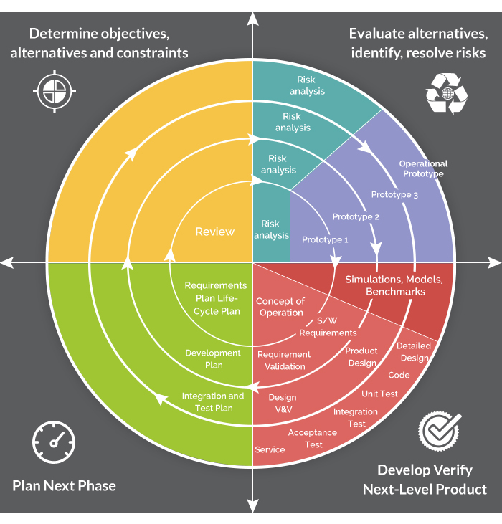

## Work Schedule

|  |  |  |
| --- | --- | --- |
| Date | Task | Responsibility |
| 11/05/2015 | Requirements Gathering | Sruthi, Twinkle, Maryellen, Barbara |
| 11/08/2015 | Software Architecture Analysis & Design | Twinkle, Sruthi, Barbara |
| 11/09/2015 | Developers | Twinkle, Maryellen |
| 11/28/2015 | Testers | Barbara, Sruthi |
| 12/08/2015 | User Demo | Barbara,Sruthi, Maryellen, Twinkle |

## Software Architecture

## Abstract Data Style (OO-Oriented)

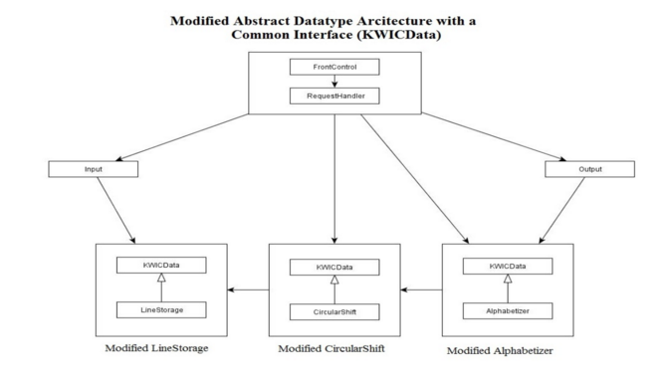

## 3-Tier Architecture

This Architecture based on MVC design pattern is used as basis to build and implement the Cyber miner. The final product of the project will have applet is embedded in web browser using web tier JSP pages which will intern connected to Business Tier with various classes as displayed below in class diagram to perform Cyberminer search system with KWIC system. JDBC with MySql is used to store and retrieve the description and URL after KWIC indexing is complete.

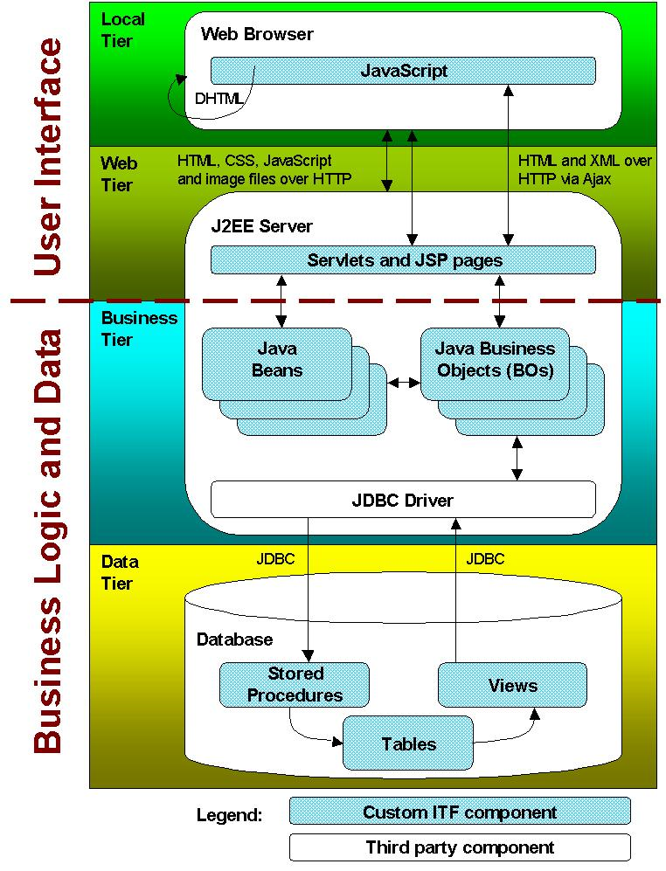

## Design Pattern - Façade pattern

This provides a simplified interface to a larger body of code, such as a class library. In addition, the user can just directly interact with one interface to access both KWIC indexing and cyber miner systems.

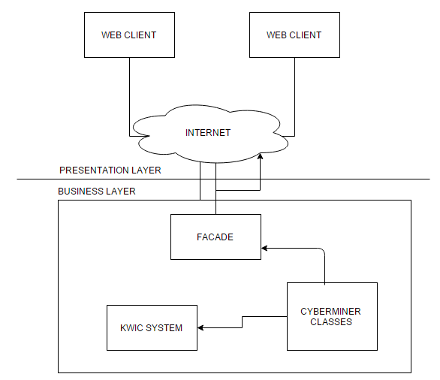

## Architectural Views

## Logical View

* + 1. **Class Diagram**

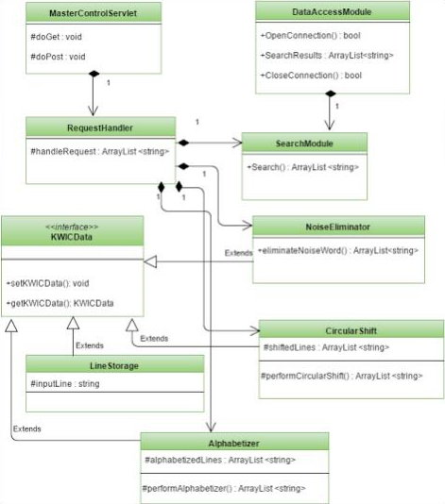

## Process View

* + 1. **Sequence Diagram**

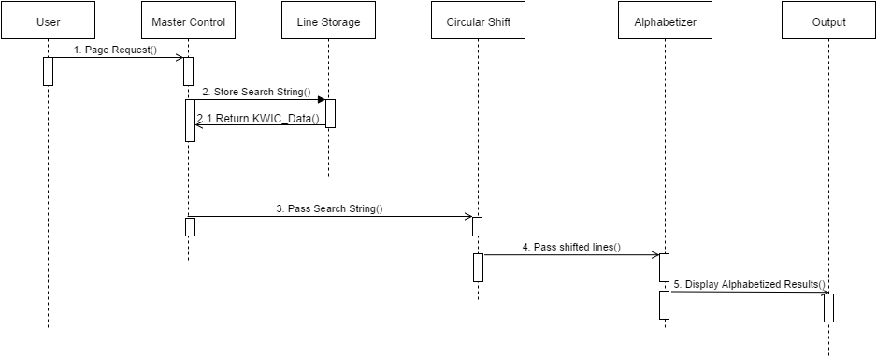

* 1. **Use Case View**
     1. **Use Case Diagram- version 1**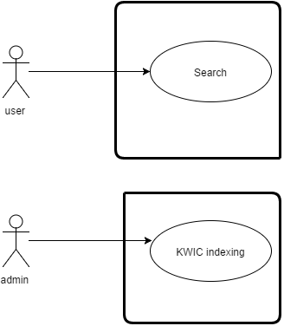
     2. **Use Case Diagram- version 2**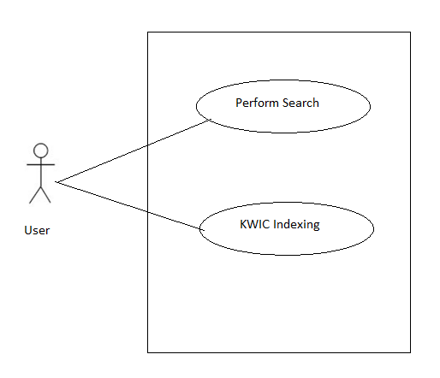

## Traceability Matrix

## 

## References

* http://www.utdallas.edu/~chung/SA/syllabus.htm
* *Documenting Software Architectures: Views and Beyond,*P. Clements, F. Bachmann, L. Bass, D. Garlan, J. Ivers, R. Little, R. Nord and J. Stafford, MA: Addison-Wesley, 2003